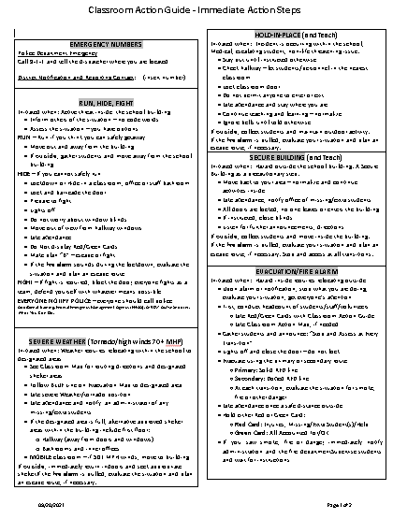

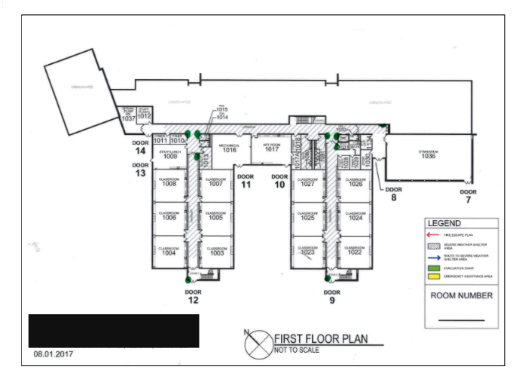

Location:
- All classroom and officer area at room or main officer area exit.
  - Optional - all offices
  - Optional - all bathrooms
- Displayed the same way in large or small rooms, consistency is key.

Classroom Action Map Purpose:
- The map should be in every classroom and officer area.
- The map directs people using a visual on safety routes during emergencies like evacuation and severe weather.
- The map should include easy references on safer areas in the building for severe weather.
- The map should include all exterior door numbers for emergency responders.
- The map should have very few words, as visuals are faster to understand in emergencies.
- All other maps or safety reference materials dated before the recommended Classroom Action Guide and Map, should be discarded.

This is a draft Classroom Action MAP. The map should indicate the following:
- All exterior door numbers.
- Shaded areas include severe weather evacuation areas within the building.
  - The architect should be consulted on all areas identified for severe weather shelter.
  - This is an example only.
- AED – The AED should be noted on all classroom maps with a yellow box.
- Red solid line – Primary evacuation route for each room.
- Red dashed line – Secondary evacuation route.
  - Make sure the red lines go out of the building and blue lines stay within to account for individuals with color blindness.
- Blue solid line – evacuation from the room to a severe weather shelter area within the building.
  - Blue solid lines should move the room occupants to a zone or area, not a specific placement.
  - Bathrooms are the safest place in the building.
    - During drills participants should not be required to kneel and put their heads down on the floor.
- Map safety references and architect name, safety reference key and layers of the safety reference should be removed as people generally do not understand these references for the purpose of this Classroom Action Map.
- Dates should be included on the current copy, when produced.

Source:
DuPage County Regional Office of Education
John Heiderscheidt, Safety Specialist
jheiderscheidt@dupageroe.org

